FACULTY OF INFORMATION TECHNOLOGY

Operating System Lab No 2
C++ Programming
And
GNU Debugger


Faculty of Information Technology UCP Lahore Pakistan

Basic C++ programming in Linux Enviornment

Topics to be covered

- Compiling and Running a C++ Program.
- Data Type
- Input/output
- Control structures (If/else/switch)
- Looping
- Functions with/without parameters
- Command Line Arguments
- Dynamic memory allocation
- Structures

Objectives:
- Students able to understand the concept of C++ Programming in Linux Enviornment.

Pre-requisite:
- G++ installed in the system
- Visual studio code must be installed.
- Basic concept of C++

FACULTY OF INFORMATION TECHNOLOGY

Basic C++ Programming

____________________________________

Compiling and running a c++ program in Linux.

Open a file using any editor e.g. gedit hello.cpp

Write Helloworld programs

Compile using g++

g++ hello.c and run output file (./a.out) or

g++ hello.c –o myexe and run ./myexe

Data Type

Type Size (Bytes) Format Specifier
int | at least 2, usually 4 | %d
char | 1 | %c
flaot | 4 | %f
double | 8 | %lf
short int | 2 usually | %hd
unsigned int | at least 2, usually 4 | %u
long int | at least 4, usually 8 | %li
long long int | at least 8 | %lli
unsigned long int | at least 4 | %lu
unsigned long long int | at least 8 | %llu
long double | at least 10, usually 12 or 16 | %lf
signed char | 1 | %c
unsigned char | 1 | %c

Input/output

CP Task 1 (0.5 Marks)

Write a C++ program that asks the user to enter the radius of a circle. It calculates and
displays the area using the formula:

Area = π × radius² (Use 3.14159 for π)

Sample Output:

Enter the radius of the circle: 5

The area of the circle is 78.53975.

FACULTY OF INFORMATION TECHNOLOGY

Control Structures

C++ if Statement
The syntax of the if statement in C++ programming is:
if (test expression)
{
// statements to be executed if the test expression is true
}

How if statement works?
The if statement evaluates the test expression inside the parenthesis ().
If the test expression is evaluated to true, statements inside the body of if are executed. If the test expression is evaluated to false, statements inside the body of if are not executed.

C++ if...else Statement

The if statement may have an optional else block. The syntax of the if..else statement is:

}
e
// statements to be executed if the test expression is fals
else {
}
// statements to be executed if the test expression is true
if (test expression) {

How if...else statement works?
If the test expression is evaluated to true, statements inside the body of if are executed. Statements inside the body of else are skipped from execution. If the test expression is

FACULTY OF INFORMATION TECHNOLOGY
evaluated to false, statements inside the body of else are executed statements inside the body of if are skipped from execution.

CP Task 2 (0.5 Marks)

Write a C++ program that asks the user to enter three numbers and determines the greatest number among them.

SAMPLE OUTPUT:
Enter first number: 25
Enter second number: 10
Enter third number: 40
The greatest number is 40.

FACULTY OF INFORMATION TECHNOLOGY

Looping

The syntax of the loop is:

How for loop works?
}
// statements inside the body of loop

for (initializationStatement; testExpression; updateStatement)
{
for

The initialization statement is executed only once. Then, the test expression is evaluated. If the test expression is evaluated to false, the for loop is terminated. However, if the test expression is evaluated to true, statements inside the body of for loop are executed, and the update expression is updated. Again the test expression is evaluated. This process goes on until the test expression is false. When the test expression is false, the loop terminates.

CP Task 03 (0.5 Marks)

Write a program to perform sorting of numbers (Bubble Sort). The program shall take an array of 20 integers as input, if user wants to enter less than 20 numbers, user shall terminate it with -99. The program shall then sort the sequence in ascending order and print both the original and sorted sequence.

Sample Input:
Input Sequence: 15 3 2 16 7 9 12 25 5 56 8 2 -99

Sample Output:

The entered sequence is: 15 3 2 16 7 9 12 25 5 56 8 2

Updated sequence is: 2 2 3 5 7 8 9 12 15 16 25 56

Functions

A function is a block of code that performs a specific task.

#include <stdio.h> void functionName(){
} int main(){
functionName();
}

CP Task 4 (0.5)

Write a void checkEvenOdd() function that takes input from the user, checks whether the number is even or odd and displays the result on the screen.

Sample Output: - Enter the number: 17
Output: Odd Number

Command Line Arguments

Command line argument is a parameter supplied to the program when it is invoked. Command line argument is an important concept in C++ programming. It is mostly used when you need to control your program from outside. Command line arguments are

passed to the method.
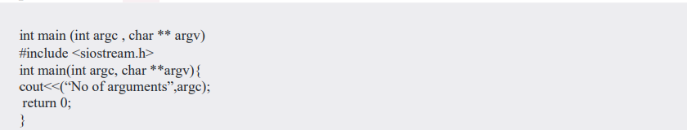
main()

CP Task 5 (0.5)

Write a C++ program to receive two integers from command line and add them.

Dynamic memory allocation

The name "malloc" stands for memory allocation.
The malloc() function reserves a block of memory of the specified number of bytes. And, which can be casted into pointers of any form.

void
it returns a pointer of

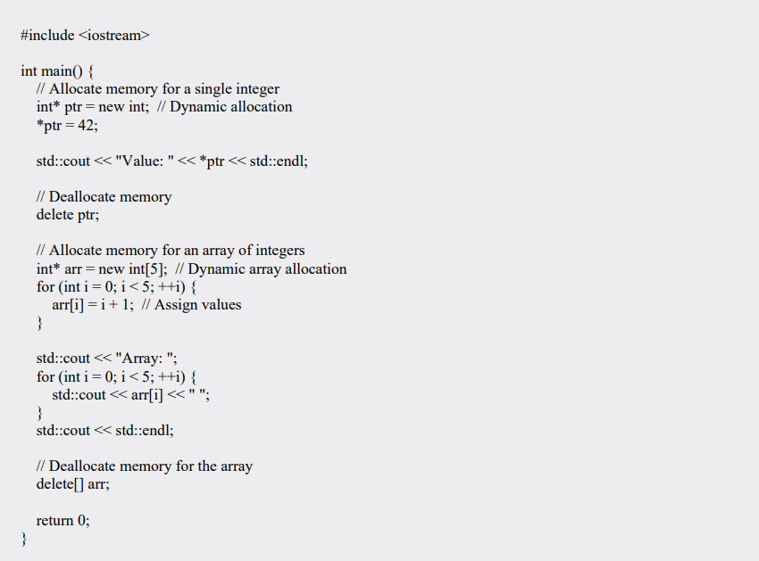

CP Task 6 (0.5)

Write a C++ program to display second max number in an array. User enter integers and you need to calculate the size of array and allocate run time memory for array.

Sample Output: -
Enter the array elements: = ./a.out 1 2 3 4 5 6 7 8 9 0 Output:
9

Structures

Syntax of struct
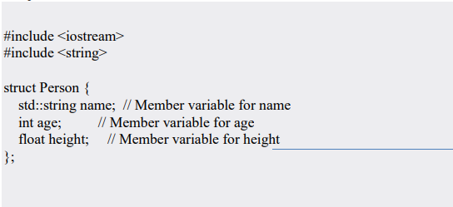

CP Task 7 (0.5)

Write a C++ program stores the information (id, name, age and pay) of an employee and displays it on the screen using structures
(Incorporated by Ordinance No. XXIV of 2002 promulgated by Government of the Punjab)

FACULTY OF INFORMATION TECHNOLOGY

CP Task 8 (10.5)

You are given a file “task1.txt” containing record of 10 employees (Fig. 1). Write a C++ program to manage employee’s information using structures. The information of an employee contains ID (i.e. Emp01), Name (i.e. without space), gender (i.e. m/f), job position (i.e. internee/developer without spaces), experience in years (i.e. 1/2) and pay. All the data will be saved to a file in specific format as depicted in Fig. 1. Maximum number of employees are 100. The program will prompt the user a Menu for different operations as shown below:

==================== MENU ===================
- Add a record
- Search a record by ID
- Show all records
- Show employees having pay less then basic pay (20000)
- Save and exit

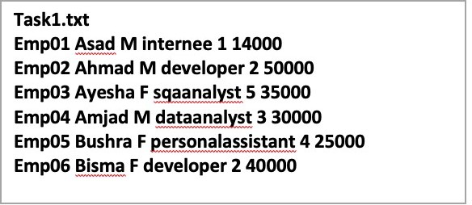

Fig. 1. File format (ID Name Gender Position Pay)

Hint. You can read all the records at a time using structures array. You can update file by opening it in append mode.

Functions prototype

void printStd(employee tmp) void readData(employee rec[], int &count) void addRecord(employee rec[], int
*count) void searchByID(char reg[], employee rec[], int count) void showAllRecord(employee rec[], int count)
void showBelowBasicpay(employee [], int count, int basicpay)

